

AP® Physics C
1979 Free Response Questions

The materials included in these files are intended for use by AP teachers for course and exam preparation in the classroom; permission for any other use must be sought from the Advanced Placement Program®. Teachers may reproduce them, in whole or in part, in limited quantities, for face-to-face teaching purposes but may not mass distribute the materials, electronically or otherwise. These materials and any copies made of them may not be resold, and the copyright notices must be retained as they appear here. This permission does not apply to any third-party copyrights contained herein.

These materials were produced by Educational Testing Service® (ETS®), which develops and administers the examinations of the Advanced Placement
Program for the College Board. The College Board and Educational Testing Service (ETS) are dedicated to the principle of equal opportunity, and their
programs, services, and employment policies are guided by that principle.

The College Board is a national nonprofit membership association dedicated to preparing, inspiring, and connecting students to college and opportunity.
Founded in 1900, the association is composed of more than 4,200 schools, colleges, universities, and other educational organizations. Each year, the
College Board serves over three million students and their parents, 22,000 high schools, and 3,500 colleges, through major programs and services in
college admission, guidance, assessment, financial aid, enrollment, and teaching and learning. Among its best-known programs are the SAT®, the
PSAT/NMSQT®, and the Advanced Placement Program® (AP®). The College Board is committed to the principles of equity and
excellence, and that commitment is embodied in all of its programs, services, activities, and concerns.

APIEL is a trademark owned by the College Entrance Examination Board. PSAT/NMSQT is a registered trademark jointly owned by the College Entrance Examination Board and the National Merit Scholarship Corporation. Educational Testing Service and ETS are registered trademarks of Educational Testing Service.

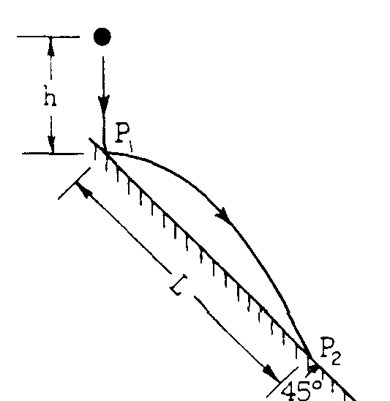
1979M1. A ball of mass m is released from rest at a distance h above a frictionless plane inclined at an angle of 45° to the horizontal as shown above. The ball bounces elastically off the plane at point P₁ and strikes the plane again at point P₂. In terms of g and h determine each of the following quantities:
a. The velocity (a vector) of the ball just after it first bounces off the plane at P₁.
b. The time the ball is in flight between points P₁ and P₂.
c. The distance L along the plane from P₁ to P₂.
d. The speed of the ball just before it strikes the plane at P₂.
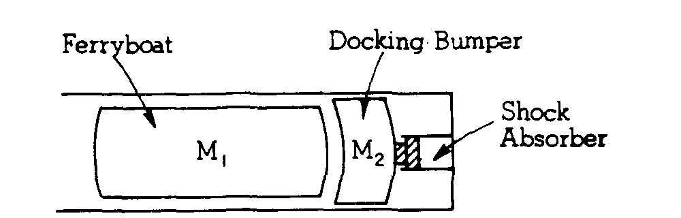

1979M2. A ferryboat of mass M₁ = 2.0 x 10⁵ kilograms moves toward a docking bumper of mass M₂ that is attached to a shock absorber. Shown below is a speed v vs. time t graph of the ferryboat from the time it cuts off its engines to the time it first comes to rest after colliding with the bumper. At the instant it hits the bumper, t = 0 and v = 3 meters per second.
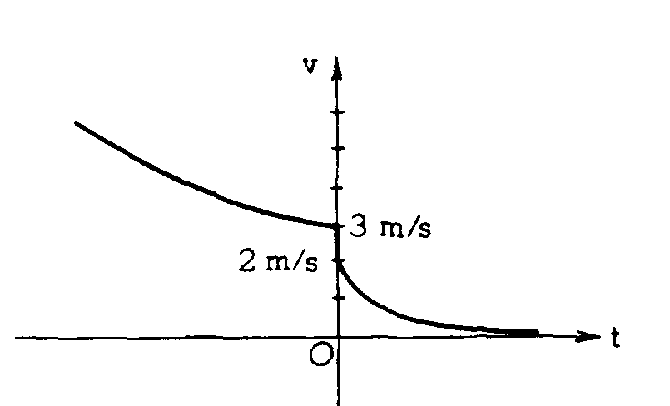
a. After colliding inelastically with the bumper, the ferryboat and bumper move together with an initial speed of 2 meters per second. Calculate the mass of the bumper M₂.
b. After colliding, the ferryboat and bumper move with a speed given by the expression v = 2e^{-4t}. Although the boat never comes precisely to rest, it travels only a finite distance. Calculate that distance.
c. While the ferryboat was being slowed by water resistance before hitting the bumper, its speed was given by 1/v = 1/3 + βt, where β is a constant. Find an expression for the retarding force of the water on the boat as a function of speed.

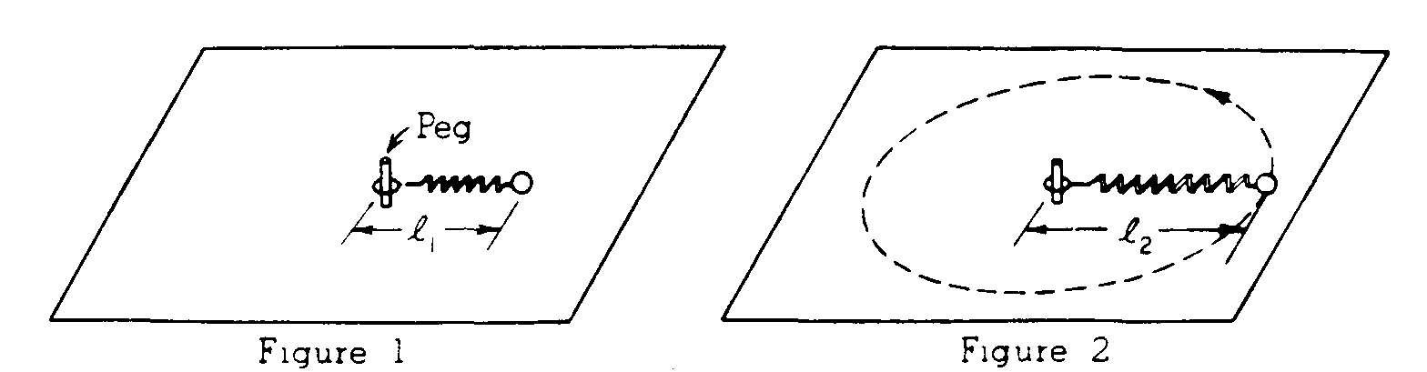
1979M3. A mass m constrained to move on a frictionless horizontal surface is attached to a frictionless peg by a massless spring having force constant k. The unstretched length of the spring is l₁, as shown in Figure 1.
When the mass moves in a circle about the peg with constant angular velocity ω_{o}. the length of the spring is l₂ as shown in Figure 2. Express your answers to parts a, b, and c in terms of m, k, ω_{o} and l₁.
a. Determine the length l₂
b. Assume the total energy of the system in Figure 1 is zero. Determine the total energy of the rotating system in Figure 2.
c. Determine the magnitude of the angular momentum of the system.

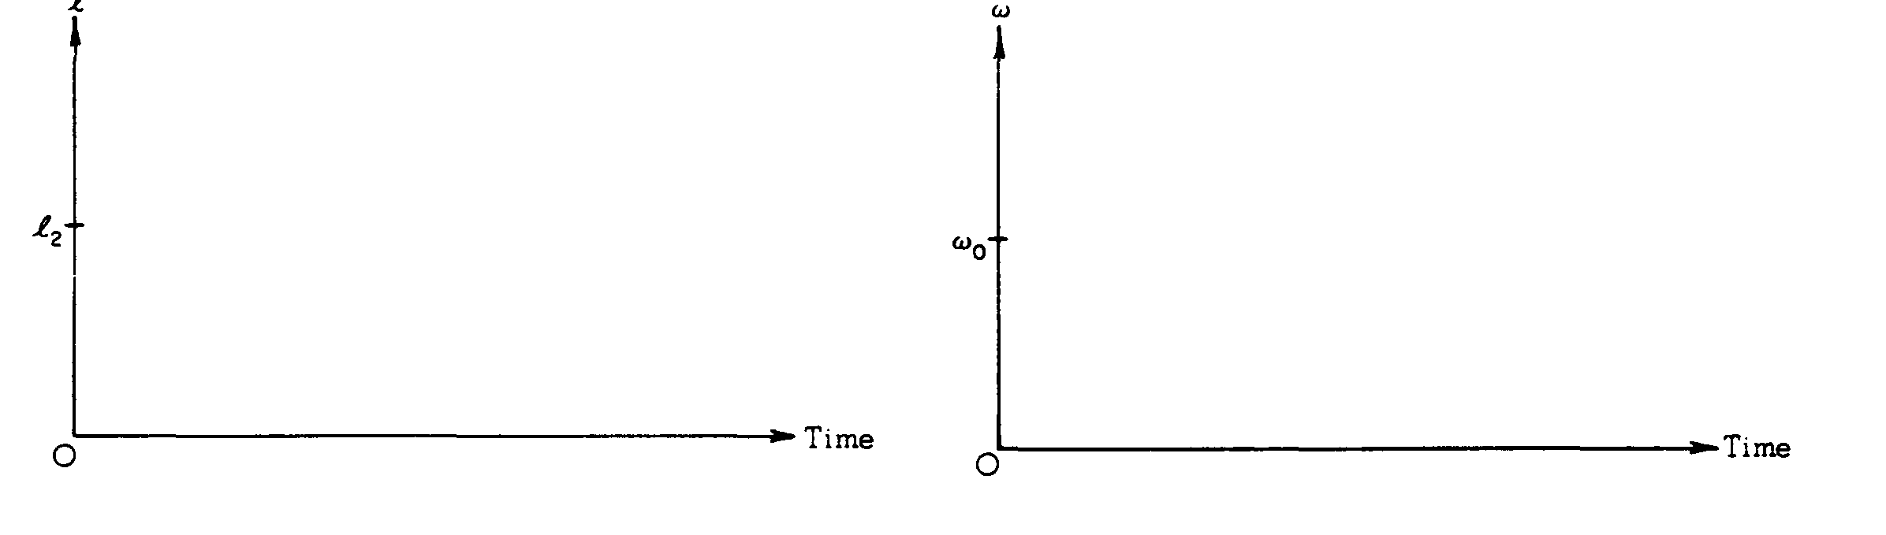
d. While the mass is rotating about the peg with angular velocity ω_{o}, it is struck by a hammer that provides a small impulse directed inward. On the axes below, sketch graphs to indicate qualitatively the manner in which the length of the spring l and the angular velocity ω will vary with time in the subsequent motion.
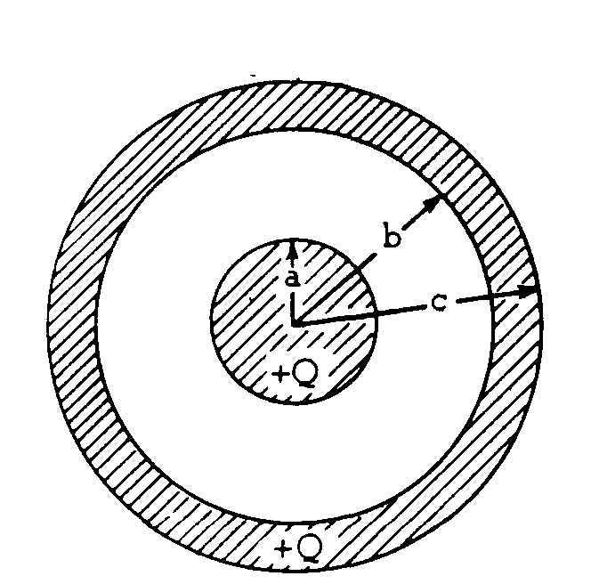
1979E1. A solid conducting sphere of radius a is surrounded by a hollow conducting shell of inner radius b and outer radius c as shown above. The sphere and the shell each have a charge +Q. Express your answers to parts (a), (b) and (e) in terms of Q, a, b, c, and the Coulomb's law constant.
a. Using Gauss's law, derive an expression for the electric field magnitude at a < r < b, where r is the distance from the center of the solid sphere.
b. Write expressions for the electric field magnitude at r > c, b < r < c, and r < a. Full credit will be given for statements of the correct expressions. It is not necessary to show your work on this part.
c. On the axes below, sketch a graph of the electric field magnitude E vs. distance r from the center of
the solid sphere.
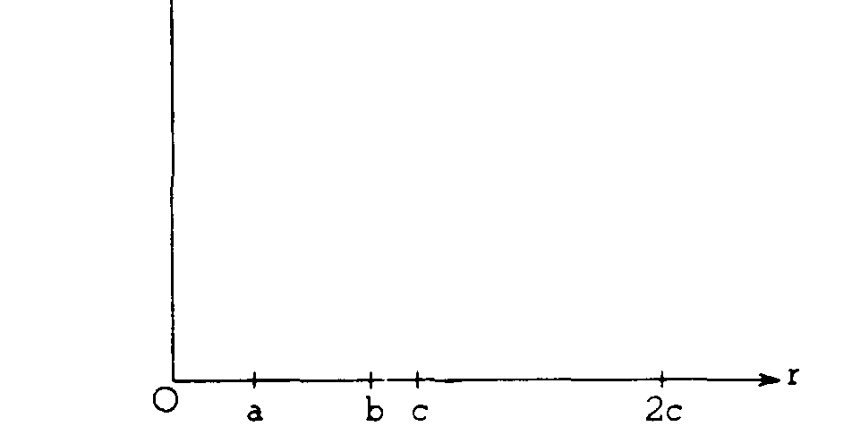
E
d. On the axes below, sketch a graph of potential V vs. distance r from the center of the solid sphere. (The potential V is zero at r = ∞.)

V
e. Determine the Potential at r = b.

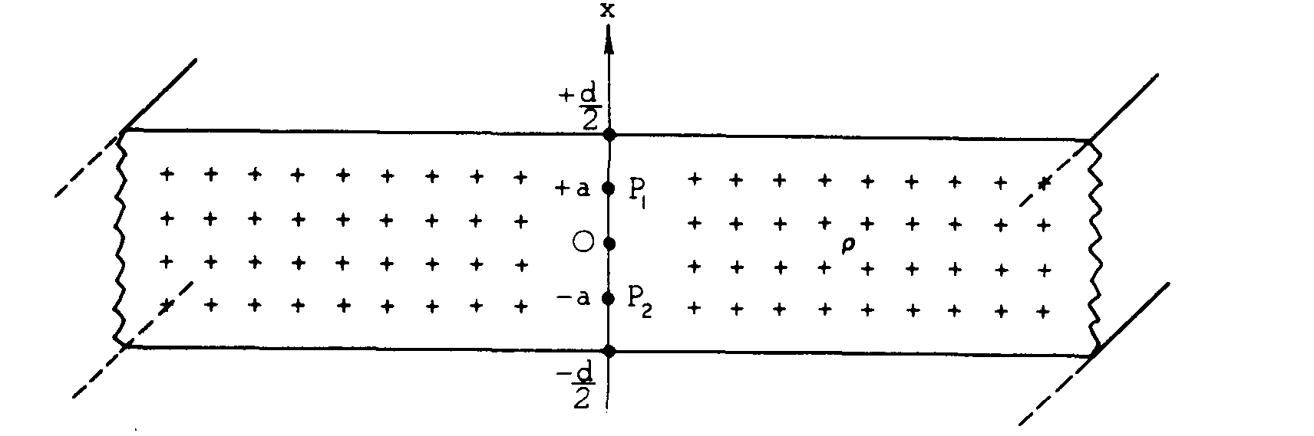
1979E2. A slab of infinite length and infinite width has a thickness d. Point P₁ is a point inside the slab at x = a and point P₂ is a point inside the slab at x = -a. For parts (a) and (b) consider the slab to be nonconducting with uniform charge per unit volume ρ as shown.
a. Sketch vectors representing the electric field E at points P₁ and P₂ on the following diagram.
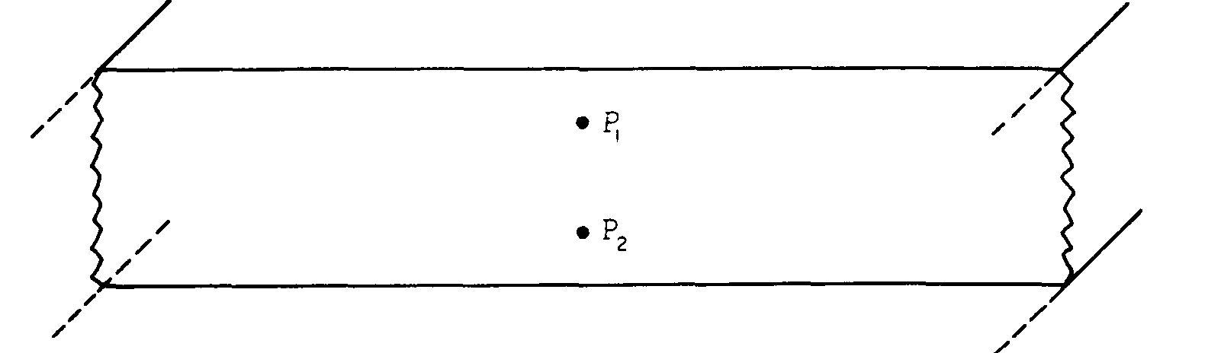
b. Use Gauss's law and symmetry arguments to determine the magnitude of E at point P_{l}.

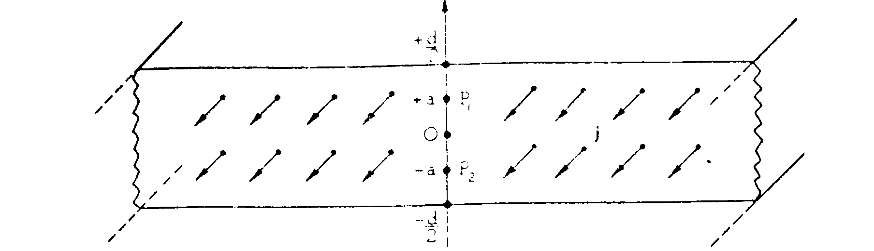
For parts (c) and (d), consider the slab to be conducting and uncharged but with a uniform current density j directed out of the page as shown below.
c. Sketch vectors representing the magnetic field B at points P₁ and P₂ on the following diagram.
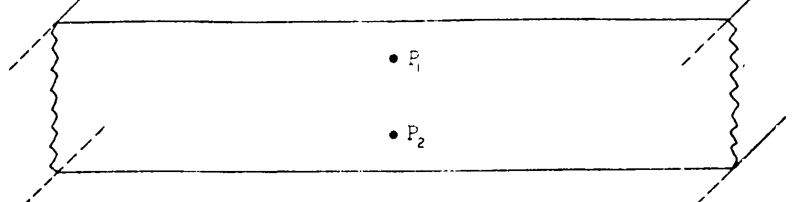
d. Use Ampere’s law and symmetry arguments to determine the magnitude of B at point P₁.
1979E3. A uniform magnetic field exists in a region of space. Two experiments were done to discover the direction of the field and the following results were obtained.

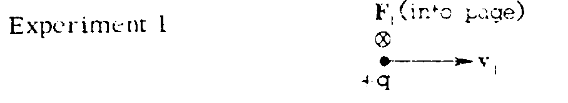
A proton moving to the right with instantaneous velocity v₁ experienced a force F₁ directed into the page, as shown above.
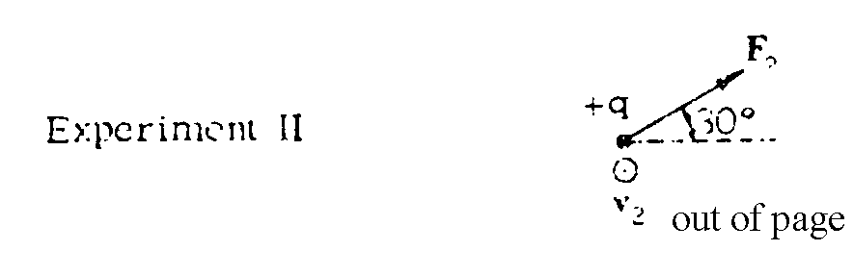
A proton moving out of the page with instantaneous velocity v₂ experienced a force F₂ in the plane of the page as shown above.

a. State the direction of the magnetic field and show that your choice accounts for the directions of the forces in both experiments.
b. In which experiment did the proton describe a circular orbit? Explain your choice and determine the radius of the circular orbit in terms of the given force and velocity for the proton and the proton mass m.
c. Describe qualitatively the motion of the proton in the other experiment.

